Table of Contents
Table of Figures 3
Table of Tables 3
Abstract 4
Introduction 4
Background 5
Examining the OECD climate-related funding 6
Data and Methodology 10
Multilateral Project Data Collection and Flagging 11
Rural Agricultural Economies Flag and On-Farm Flag 12
Climate/Climate Change Flag 12
Climate Risk and Vulnerability Data 13
Analysis 13
Data Processing 13
Analyzing Climate-Related Proportion of Agriculture Lending 14
Analyzing Country-Level Climate-Related Agriculture Borrowing 15
Results 15
Categorization of multilateral financing projects 15
Climate-Related Rural/Agricultural Financing 15
Climate-Related On-Farm Financing 18
Agricultural Emphasis Within Climate Lending 19
Country-Level Analysis of Climate-Related Agriculture Borrowing 22
Limitations 25
Areas for Future Research 26
Conclusion 26
References 27
Appendices 29
Appendix A: On-farm and rural agricultural economies categorization 29
Appendix B: Average annualized borrowing amount (2019 USD) for climate-related rural agricultural economies projects by country. 39
Appendix C: Proportion of average annualized borrowing (2019 USD) for climate-related rural agricultural economies projects among all rural agricultural funding by country. 41
Appendix D: Average annualized borrowing amount (2019 USD) for climate-related on-farm projects by country. 44
Appendix E: Proportion of average annualized borrowing (2019 USD) for climate-related on-farm projects among all on-farm funding by country. 46
Appendix F: Key for project standardization 49

Table of Figures
Figure 1: Climate-related funding globally, 2000-2019 (in 2019 $ USD) 8
Figure 2: Climate-related funding to sub-Saharan Africa, 2000-2019 (in 2019 $ USD) 9
Figure 3: Climate-related funding to sub-Saharan Africa for agriculture projects, 2000-2019 (in 2019 $ USD) 10
Figure 4: Schematic of data extraction and processing methods. 11
Figure 5: Flow chart of study inclusion steps to reach the sample dataset 14
Figure 6: Projects identified as being related to climate, rural agricultural economies, and on-farm activities among all multilateral financing projects. 15
Figure 7: Proportion of climate-related rural agricultural spending by multilateral institution. 17
Figure 8: Proportion of climate-related on-farm activities spending by financing institution. 19
Figure 9: Proportion of rural/agricultural economies-focused climate spending by financing institution. 21
Figure 10: Proportion of on-farm focused climate spending by financing institution. 22
Figure 11: Average annualized borrowing amount (2019 USD) for climate-related rural agricultural economies projects by country. 23
Figure 12: Proportion of average annualized borrowing (2019 USD) for climate-related rural agricultural economies projects among all rural agricultural funding by country. 24
Figure 13: Proportion of climate-related rural/agricultural economies borrowing among all rural/agricultural financing by Climate Risk Index. 25

Table of Tables
Table 1: Proportion of climate-related rural agricultural financing projects by multilateral institution. 16
Table 2: Proportion of climate-related rural agricultural spending by multilateral institution. 17
Table 3: Proportion of climate-related on-farm activities financing projects by multilateral institution. 18
Table 4: Proportion of rural agricultural economies-focused climate financing projects by financing institution. 20
Table 5: Proportion of on-farm-focused climate financing projects by financing institution. 20

Abstract
Climate change is predicted to have increasingly dire effects on the largely rainfed agriculture of sub-Saharan agriculture, a livelihood that also contributes to climate change. Within this context, multilateral funding institutions are increasingly funding projects devoted to the adaptation to or mitigation of climate change. Data from the Organisation for Economic Development (OECD) provide an overview of climate-related project data, but the intersection of climate-related projects and projects intended to develop rural and agricultural economies is less explored. This paper focuses on climate-related projects in sub-Saharan Africa in the context of rural and agricultural project funding. We use a custom dataset from three separate multilaterals (the World Bank, African Development Bank, and International Fund for Agricultural Development) to answer the following research questions:
- What proportion of agriculture-related lending across the three multilaterals of interest has a climate component?
- Which countries are borrowing most for climate-related agricultural projects? Is the amount of borrowing correlated with a country’s climate risk?

Of all financing projects in our dataset (N = 1,846), we identified 203 as being climate-related (11%) and 505 as being related to rural agricultural economies (27%). Of the $26.5 billion annualized project funding, rural and agricultural financing accounts for $6.5 billion (24.6%) while climate projects receive $1.97 billion (7.4%). The World Bank funds approximately half of all agriculture projects in the dataset, with the AfDB funding just under 30% and IFAD just over 20%.
Annual average borrowing amounts from multilaterals for climate-related rural/agricultural economies projects varies widely across sub-Saharan Africa. The major borrowers include Ethiopia ($150 million), Nigeria ($105 million), and Kenya ($102 million). The proportion of multilateral borrowing for climate-related projects among all rural agricultural borrowing also varies substantially across sub-Saharan Africa; the Seychelles and Eswatini devote the largest proportions of rural agricultural borrowing toward climate work (100% and 69.8%, respectively). Fourteen SSA countries devote between 15% and 30% of rural agricultural borrowing to climate-related projects and fifteen have not received any multilateral financing for climate-related rural/agricultural economies projects.
We do not find a statistically significant relationship between a country’s Climate Risk Index and the proportion of annual rural/agricultural economies borrowing focused on climate.

Introduction
Investing in agricultural transformation and rural development has traditionally been primarily concerned with increasing productivity. Climate change has forced a reckoning of both the carbon footprint of agriculture and long supply chains and the immediate imperative to improve the adaptive capacity of small-scale producers (SSPs). Supporting low- and middle-income country (LMIC) adaptation and even mitigation, however, takes resources. The 26th UN Climate Change Conference of the Parties stressed the critical role of mobilizing funding from public, private, and alternative sources to address climate change in LMICs, where the majority of small-scale producers (SSPs) live and where the disproportionate impacts of climate change are expected (McGuigan et al., 2002).
This paper examines an important subset of public funding to sub-Saharan African countries for projects related to climate change within agricultural sectors. We begin with some background and a brief overview of official development assistance (ODA) from bilateral and multilateral funders using the climate-related development finance dataset provided publicly by the OECD. We follow this with a more detailed look at current agricultural funding from three large multilateral funding institutions – the World Bank, the African Development Bank (AfDB), and the International Fund for Agricultural Development (IFAD) – to examine the proportion of climate-related investments within their universe of agricultural projects. The overlap between climate and agricultural funding may be one signal of a country’s financial commitment to address climate change within their agriculture sector. With this latter unique dataset, we explore the following research questions:
- What proportion of agriculture-related lending across the three multilaterals of interest has a climate component?
- Which countries are borrowing most for climate-related agricultural projects? Is the amount of borrowing correlated with a country’s climate risk?

Background
Research is establishing a complex feedback loop between agriculture and climate change. The FAO estimates that agriculture, forestry, and other land use (AFOLU) generates approximately one quarter of human greenhouse gas (GHG) emissions, while the Intergovernmental Panel on Climate Change (IPCC) estimates range from 13-21% (FAO, 2022b; Gert-Jan Nabuurs et al., n.d.). AFOLU activity is also the largest contributor of non-CO₂ GHGs such as methane (UNCC, 2014). At the same time, AFOLU absorbs 26% of the economic impact of climate disasters and one-third of human CO₂ emissions (FAO, 2022b; Gert-Jan Nabuurs et al., n.d.). Climate change impacts agricultural livelihoods through increasing heat, precipitation, and wind volatility and extreme events, all of which can reduce crop and livestock yields and compromise land and water assets (UNCC, 2014). Small and family farms – which make up the majority of farms globally – are particularly vulnerable to declines in yield (Lowder et al., 2016). Climate change is “expected to push 122 million more people, mainly farmers, into extreme poverty by 2030” (FAO, 2022b). The expected effect of climate change on all industries has prompted several organizations to begin tracking climate project spending.
Multilateral funding institutions (also referred to as multilaterals) are international financial institutions (IFIs) that provide loans and grants to recipient nations. Multilaterals are primarily funded by bilateral donors and provide funding across multiple sectors in varying amounts. Multilaterals make up approximately one third of total official development assistance (ODA) funding (OECD, n.d.-c). As of 2019, official development assistance makes up between 0.1% (Angola) and 31.6% (Central African Republic) of Gross National Income (GNI) for sub-Saharan African countries, suggesting that such funds can be a significant source of these countries’ revenues (World Bank, 2019). Financial assistance in the form of aid from high-income countries to LMICs has been a component of national budgets for over 70 years.
As non-environmental institutions, multilateral banks have the means to contribute to a country’s investment priorities in climate change and have made progress in their attempts to do so, though these remain insufficient (Rayner et al., 2021). For example, the African Development Bank is the implementing agency of the $8.5 billion Climate Investment Fund that “provides developing countries with grants, concessional loans, risk mitigation instruments, and equity that leverage significant financing from the private sector, multilateral development banks, and other sources” (African Development Bank, 2019). While multilateral investment does not necessarily indicate how committed a government is to combating climate change, it can indicate that climate protection is becoming a priority of global project financing (Hefeker, 2006; Ahamer, 2021).
Other information on country commitments to combating climate change exist, however this is primarily in the form of extensive reports or other complex qualitative data. For example, countries have communicated their post-2020 climate actions in the form of Intended Nationally Determined Contributions (INDCs), which detail their commitments to achieving the goals of the Paris Agreement (World Resources Institute, n.d.). However, such documents focus primarily on climate mitigation (i.e. reducing emissions) rather than a broader view of climate resilience; climate adaptation commitments, when described, are typically in an annex (FAO, 2022a). Furthermore, they record intentions rather than actions already taken. Multilateral investments in climate-related projects have the advantages of both allowing a broader view of a country’s actions towards combating climate change and showing actions in the forms of dollars committed to actual projects.
For the past twenty years climate-related development finance has become an increasingly important focus of ODA. Since 1998 the OECD has categorized official development assistance (ODA) from bilateral funders as targeting climate change using the “Rio Markers”, a methodology designed after the Rio Conventions were agreed to at the Earth Summit in 1992 (OECD, n.d.-b; Simon, 2018). However, the OECD’s Development Assistance Committee’s (DAC) Secretariat only requires this categorization from bilateral funders; multilateral funders do not follow a consistent methodology for reporting climate-related aid. Some (including IFAD) use the Rio Markers, while others (including the AfDB and World Bank) use a “climate components methodology” based on the Common Principles for Climate Change Mitigation Finance Tracking agreed to by a group of multilateral development banks in 2015 (OECD, n.d.-d; World Bank, n.d.). These methodologies allow the OECD to track what proportion of funds support climate mitigation and climate adaptation strategies, however they focus primarily on bilateral flows. For example, in 2018-2019 27% of bilateral ODA had climate objectives of some form, with the majority of those focused on climate mitigation in Asia (OECD, 2022).
The OECD does present project-level data on climate-related development finance from multilaterals, but they do not present total commitment amounts, nor do they analyze the overlap between agriculture-related and climate-related projects (OECD, n.d.-a). Before presenting the agricultural funding data collected and analyzed from the three multilaterals of interest, we first examine these OECD data to add broader context and provide a point of comparison for our findings.

Examining the OECD climate-related funding
The OECD began tracking bilateral, multilateral, and private financing for climate-related projects as early as 2000, though regular reporting for DAC member bilaterals began in 2008 for mitigation and 2010 for adaptation. Data for multilaterals are not reported for years prior to 2013 (OECD, 2018, p. 5). The OECD project database includes rich data that distinguish between climate mitigation and adaptation projects within all project sectors (e.g., health, education, energy). According to OECD financing data, 52% of 2019 climate-related funding to sub-Saharan Africa comes from multilateral institutions, including development banks, 47% from bilateral institutions, and 1% from private donors (OECD, n.d.-a). This is consistent with global trends, as multilaterals contribute 54% of 2019 global climate-related funding, bilaterals contribute 45%, and private donors contribute <1% (OECD, n.d.-a).
Across all funding institutions, the World Bank and African Development Bank (AfDB) are the two largest contributors of climate-related ODA to sub-Saharan Africa (30% and 14%, respectively). Among multilateral funding institutions alone, the World Bank and AfDB contribute 58% and 27% of climate-related funding to Africa in 2019, respectively, while the Green Climate Fund is the third largest contributor at 6% of multilateral funding; the International Fund for Agricultural Development (IFAD) contributes 2%.
OECD data also show that global climate-related funding has increased dramatically over the past 20 years, growing from approximately $800 million in 2000 to over $80 billion in 2019 (the most recent year for which the OECD has published data). Over the course of those two decades, funding institutions committed over $535 billion to climate projects; of that, 62% was devoted to climate mitigation projects, 26% to climate adaptation projects, and 13% to projects that targeted both mitigation and adaptation (Figure 1).

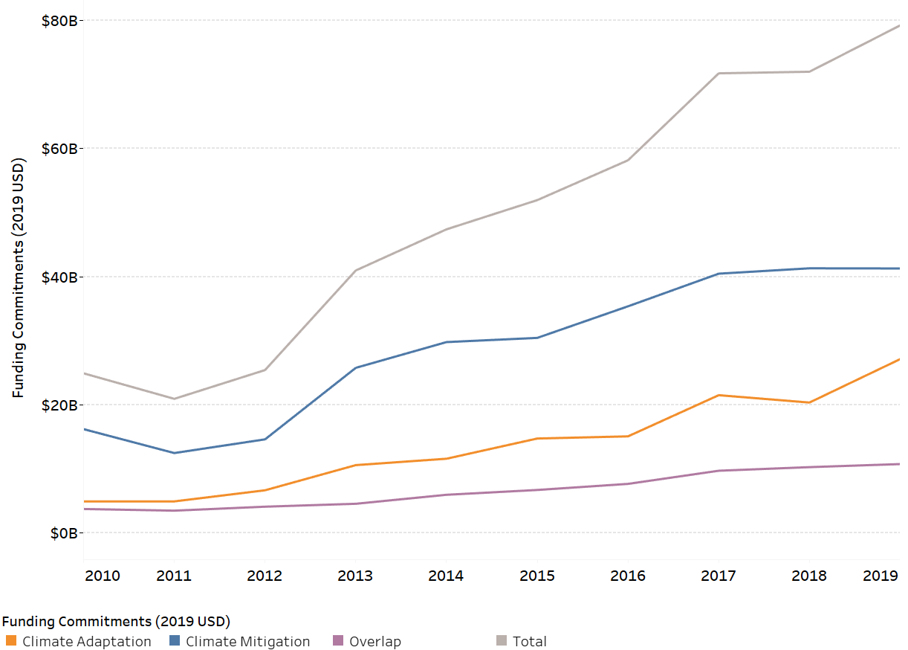
Figure 1: Climate-related funding globally, 2000-2019 (in 2019 $ USD)

Climate-related financing has seen similar growth in SSA, though at a smaller scale. SSA received $170 million in climate-related financing in 2000 and $15.1 billion in 2019 for a total of $88 billion over the two decades. Unlike the overall global financing landscape, SSA climate financing features comparable investments in climate mitigation and climate adaptation (42% and 43% over the past two decades, respectively); however, investments in overall adaptation-focused projects have begun outgrowing those in mitigation-focused projects as of 2011. Figure 2 shows this in more detail, as the blue and orange lines (mitigation and adaptation funding, respectively) overlap.
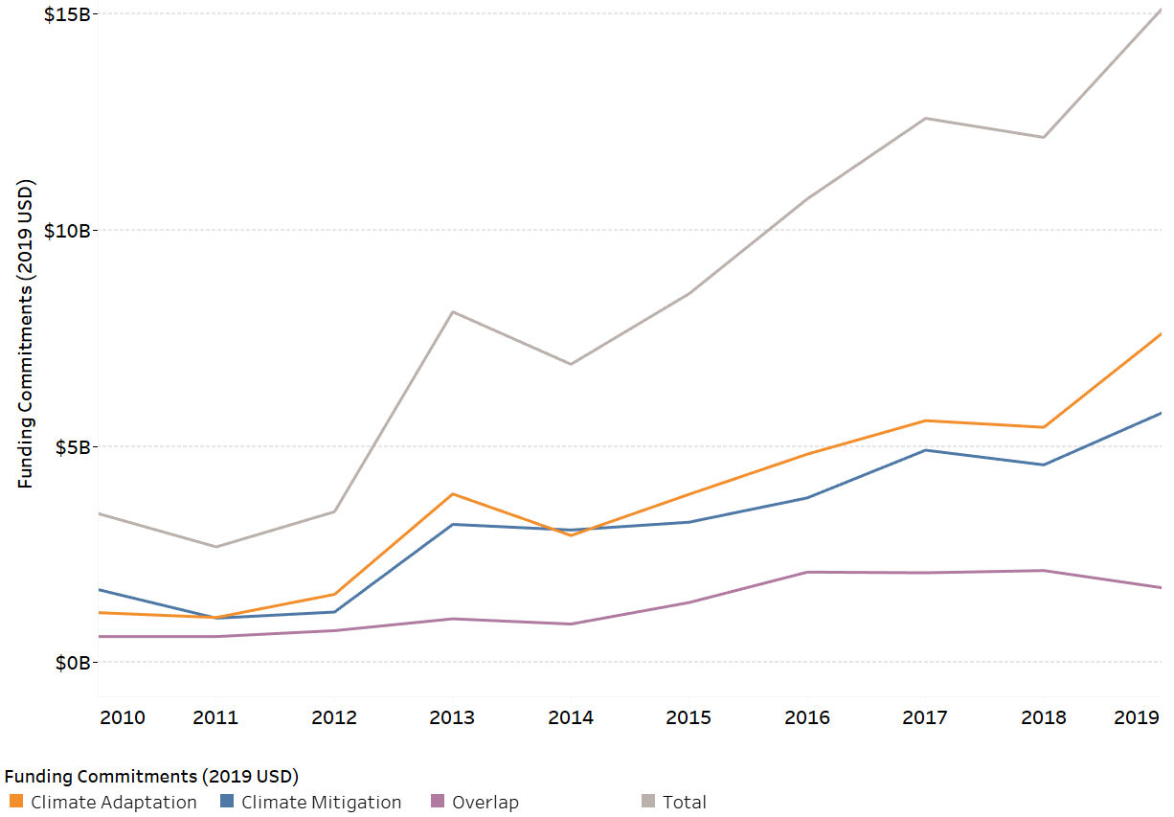
Figure 2: Climate-related funding to sub-Saharan Africa, 2000-2019 (in 2019 $ USD)

For the purposes of this project, we are interested primarily in how these climate funding priorities manifest within the agricultural sector. Figure 3 below shows how growth in sub-Saharan African agricultural climate financing projects has largely been driven by climate adaptation projects, which made up over 70% of project financing in 2019. Mitigation financing seems to have been a much lower priority for the sector since 2010.

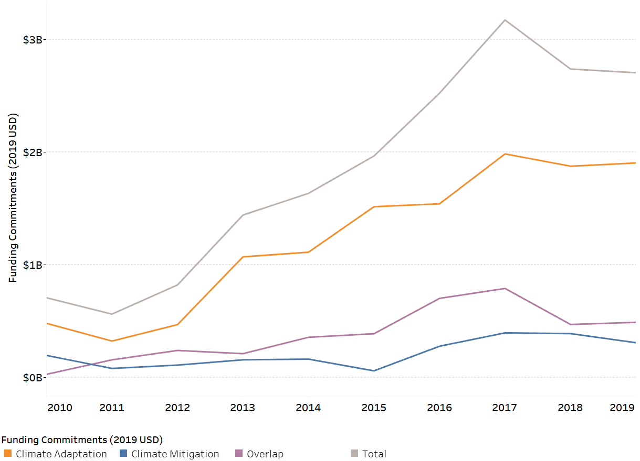
Figure 3: Climate-related funding to sub-Saharan Africa for agriculture projects, 2000-2019 (in 2019 $ USD)

The OECD data universe is climate-related ODA projects from 2000-2019. In contrast, we are most interested in the universe of agriculture-related projects, which is broader than the projects included in the OECD dataset. We look specifically at three multilateral banks with active agriculture-related projects as of 2022, and the subset of climate-related funding within that universe. While our methods for identifying climate- and agriculture-related projects are more rudimentary than the Rio Markers and “climate components methodology” used by the OECD, they are also simpler, replicable, and do not rely on self-reporting by donors.

Data and Methodology
In this section we discuss (1) the methods used to construct the database of multilateral projects and (2) country-level climate risk and vulnerability data from Germanwatch’s 2021 Global Climate Risk Index. Figure 4 provides an overview of the construction of the multilateral project database:

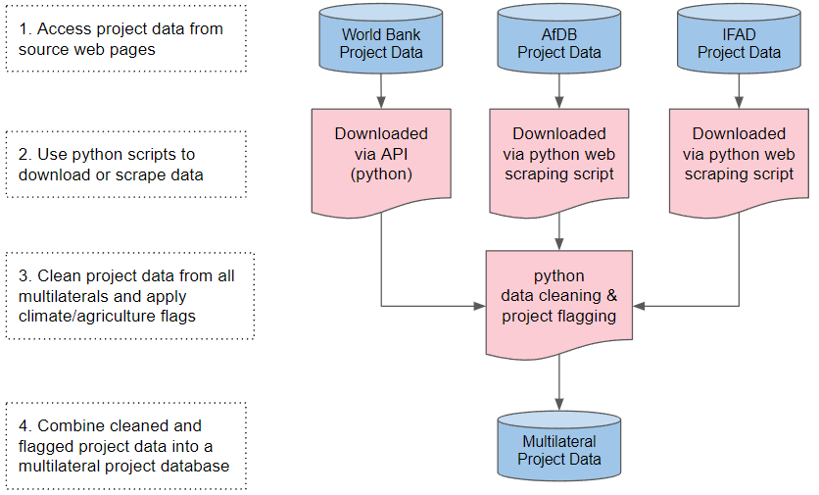
Figure 4: Schematic of data extraction and processing methods.

Multilateral Project Data Collection and Flagging
The constructed database of multilateral projects includes active, approved, under implementation, and pipeline projects from the African Development Bank (AfDB), International Fund for Agricultural Development (IFAD), and the World Bank. To capture these projects, we wrote python web scraping scripts to pull project data from individual AfDB and IFAD project web pages and used the World Bank’s Projects APIs to pull World Bank project data. These scripts only pull projects whose status is active or already approved for funding, excluding closed or completed projects. In addition, we standardize project-level data to account for minor differences in the way that multilaterals present their data. The decisions behind this standardization are outlined in Appendix F.
After compiling and standardizing all project data, we flagged projects related to three areas of interest:
- Rural agricultural economies,
- On-farm activities, and
- Climate/climate change.

The first two categories, rural agricultural economies and on-farm activities, are designations used in a prior 2021 research project to identify project relevance to smallholder agriculture. The climate/climate change flag refers to projects related to climate (independent of whether or not they relate to agriculture). Below, we discuss these designations and flagging choices in more detail.

Rural Agricultural Economies Flag and On-Farm Flag
Every project is identified by a sector code which allows for analysis and reporting on which economic sector the project is designed to support, as well as for management streams within each bank. Yet, while all three multilaterals track these data, they do not classify project sectors in consistent ways. The AfDB uses DAC sector codes while the World Bank uses a classification based on United Nations standards (IEG, 2012; Sector Coding Guide for Global Affairs Canada Partners, 2011). IFAD uses an internal sector categorization (IFAD, n.d.) with broader categories than the other two multilaterals.
We use IFAD’s sector categorization as the common baseline because we cannot disaggregate within it, and manually assign sectors to either “Rural agricultural economies” or “On-farm” categories to determine the most relevant projects. We spot check individual projects to ensure that these categories correctly capture the projects of most interest. Rural agricultural economies is a broad umbrella category that encompasses those sectors which may have an impact upon the livelihoods and well-being of small-scale producers, such as infrastructure and commercializing products. It is intended to be broadly reflective of inclusive agricultural transformation (IAT), as elaborated by de Janvry et al. (2002) and others. On-farm is a subset of the larger rural agricultural economies category, pertaining directly to small-scale land-based agriculture. Projects that did not fit into either of these categories were uncoded and deemed irrelevant to smallholder farmers in the countries of interest. (Appendix A describes which sectors were assigned to each category.)

Climate/Climate Change Flag
To identify funding projects related to climate among all agricultural and non-agricultural projects, a search string of climate-related keywords was applied to filter project titles, sectors, and descriptions. Since IFAD does not provide project descriptions online, only the titles and manually-assigned sectors for IFAD projects were searched with climate keywords. The search string was developed by testing potential keywords individually to determine if projects containing the proposed keyword had explicit climate adaptation or mitigation components; keywords that primarily matched non-climate related projects or did not match any projects were not included in the final search string. Following keyword testing, the climate search string used was
“climat*|emissions|(energy&(green&renewable&clean))| carbon|temperature|greenhouse gas”.
The terms ‘environment’, ‘ecosystem’, ‘resilience’, ‘sustainable’, ‘methane’, ‘rainfall’, ‘warming’, ‘carbon dioxide’, ‘extreme weather’, ‘sea level’, ‘conservation’, ‘green’, ‘renewable’, and ‘drought’ were excluded for yielding zero or nonspecific climate results. Note that this method of categorizing financing projects as being climate-related differs from the classification protocols such as the Rio Markers and Common Principles for Climate Change Mitigation Finance Tracking which are used by funding institutions and reported by the OECD.

Climate Risk and Vulnerability Data
In order to examine the relationship between a country’s climate risk/vulnerability and funding for climate-related rural and agricultural projects, we use Germanwatch’s 2021 Global Climate Risk Index (CRI). The CRI is an established index that indicates an historical “level of exposure and vulnerability to extreme weather events, which countries should understand as warnings in order to be prepared for more frequent and/or more severe events in the future” (David Eckstein et al., 2021). The CRI does not include vulnerability to slow-onset changes like rises in sea level or warming ocean temperatures.
The 2021 CRI report includes a 2019 index as well as an average 2000-2019 index for each country. In this analysis, we use the average 2000-2019 index to capture historical risk and reduce the impact of large single-year climate events on our analysis. We use each country’s average Climate Risk Index to compare its climate risk to its climate-related rural agricultural project commitment.

Analysis
The multilateral project database initially contained 2,480 funding projects. Project data were subsequently processed and analyzed in Stata (StataSE 16).

Data Processing
Funding projects without an assigned sector were dropped from the dataset (N = 359); since projects were categorized as relating to rural agricultural economies or on-farm activities based solely on their assigned sectors, projects missing a sector identifier were not usable for the present analysis since the research questions depend on being able to distinguish rural agricultural funding from other projects. The projects without sectors that were excluded from the dataset included 46 climate-related projects.
Several funding projects had missing or incomplete dates that required further processing. Projects that lacked both approval and closing dates were excluded from the analysis since the funding amounts could not be annualized and adjusted for inflation without knowing either the project start or end date (N = 11). For projects without durations specified in the source data, average project durations were calculated for each country-multilateral combination from the raw data and imputed for missing values (N = 535). Projects whose durations could not be imputed from country-multilateral means were assigned durations based on the average project duration for each multilateral (N = 2). Mean durations were chosen for imputation over median durations to align with data processing choices in prior analyses. Once missing project durations were imputed, missing project approval dates were calculated based on imputed durations and original completion dates (N = 15) and missing completion dates were calculated based on imputed durations and original project approval dates (N = 522). Based on the raw and imputed project date information, projects completed before May 4, 2022 were removed from the dataset since they do not represent active projects (N = 261); projects identified in the raw data as having completion dates in 2022 without any month or day information were maintained in the dataset and are considered active (N = 19).
Funding amounts were adjusted for inflation and annualized based on project duration. All lending amounts were standardized to 2019 US dollars based on the 2019 average CPI and annual average CPI values corresponding to the – raw or imputed – project approval years (Bureau of Labor Statistics, 2020). The 2022 CPI was defined as the average CPI for January through April. Projects with funding amounts of $0 were excluded from the dataset (N = 3). Once loan amounts were adjusted for inflation, total project amounts were annualized by dividing total funding by the project duration – raw or imputed – for each project. At the conclusion of data processing, the dataset contained 1,846 unique funding projects. Figure 5 below provides an overview of this exclusion process.

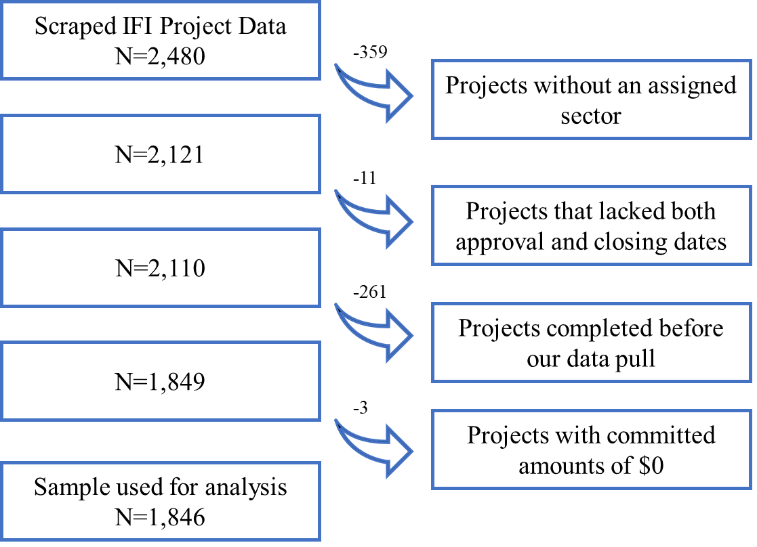
Figure 5: Flow chart of study inclusion steps to reach the sample dataset

Analyzing Climate-Related Proportion of Agriculture Lending
To determine the proportion of agriculture-related multilateral lending to sub-Saharan Africa with a climate component, we filter our dataset to lending projects identified as being related to rural agricultural economies. We then generate counts and proportions of climate-related projects by lending institution; we replicate this for on-farm projects, as a subset of rural agricultural economies lending. Next, we aggregate annualized funding amounts for climate-related rural agricultural economies projects by multilateral and calculated the proportion of climate-related spending among all rural agricultural funding for each multilateral; this was also repeated for on-farm projects. Finally, we calculate the proportion of rural agricultural economies funding among all climate-related funding from each multilateral and repeat this for on-farm projects to assess shares of agricultural financing within climate-related lending.

Analyzing Country-Level Climate-Related Agriculture Borrowing
We also investigate which sub-Saharan African countries have been borrowing the most for climate-related rural/agricultural economies projects. We generate a ranked list of countries ordered by aggregated, annualized funding amounts for climate-related rural agricultural projects. We also rank countries by the proportion of climate-related rural agricultural funding relative to all multilateral financing per country. We then run a correlation between each country’s proportion of climate-related rural agricultural funding and average 2000-2019 Climate Risk Index to determine if climate risk exposure and vulnerability are correlated with rural agricultural lending priorities.

Results

Categorization of multilateral financing projects
Of all financing projects in our dataset (N = 1,846), we identified 203 as being climate-related (11%) and 505 as being related to rural agricultural economies (27%). Among rural agricultural projects, 388 are related to on-farm activities (77% of rural agricultural projects and 21% of all projects). Rural agricultural financing ($6.52 billion) accounts for 24.6% of all annualized project funding ($26.5 billion), while climate projects only represent 7.4% of lending ($1.97 billion). As our focus is on climate-related funding for agriculture, much of the rest of our analyses will pertain to spending among rural agricultural projects only (N = 505) and its subset of on-farm projects (N = 388).
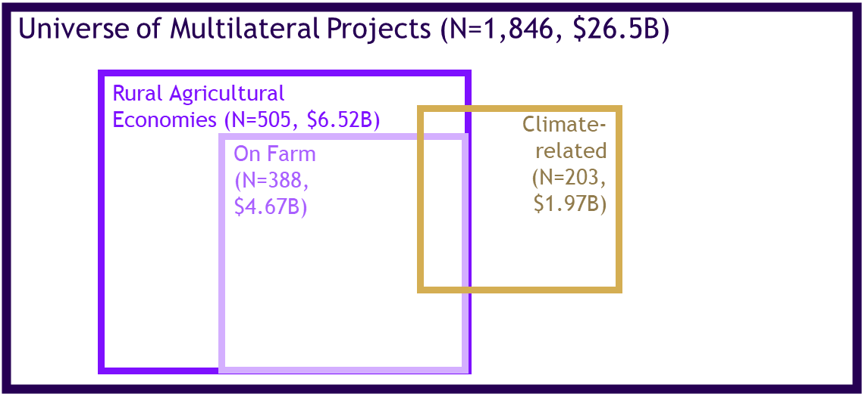
Figure 6: Projects identified as being related to climate, rural agricultural economies, and on-farm activities among all multilateral financing projects.

Climate-Related Rural/Agricultural Financing
We use the processed project data to address our primary research questions, beginning with the proportion of the three multilaterals’ agriculture-related lending with a climate component. Among the three multilaterals, the World Bank funds approximately half of all agriculture projects, with the AfDB funding just under 30% and IFAD just over 20%. We found that only 6.6% of current IFAD rural agriculture-related projects are also climate-related. The proportion of rural agricultural World Bank projects that are also climate-related is nearly double that number, 12.4%, while the AfDB has a much higher proportion of agriculture projects that are climate-related: 35.7%.

Table 1: Proportion of climate-related rural agricultural financing projects by multilateral institution.
Multilateral | Climate-Related Rural Agricultural Projects | Non-climate Related Rural Agricultural Projects | Total Rural Agricultural Projects
World Bank | N = 32  12.4% | N = 227  87.6% | N = 259  100%
AfDB | N = 50  35.7% | N = 90  64.3% | N = 140  100%
IFAD | N = 7  6.6% | N = 99  93.4% | N = 106  100%
Total | N = 89  17.6% | N = 416  82.4% | N = 505  100%

In terms of rural/agricultural dollars committed to climate-related projects (as opposed to the number of relevant projects) we see a similar rank among the multilaterals. IFAD commits just 3.5%, or $20.6 million, of its average annual agriculture-related funds to climate-related projects. The World Bank commits 11.5%, or $590 million, to similar projects, while the AfDB commits 29.8% and $243 million to climate-related agriculture projects.

Table 2: Proportion of climate-related rural agricultural spending by multilateral institution.
Multilateral | Annual Climate-related Rural Agricultural Financing | Total Annual Rural Agricultural Financing | Proportion of Climate-related Rural Agricultural Financing
World Bank | $590 million | $5.19 billion | 11.5%
AfDB | $243 million | $816 million | 29.8%
IFAD | $20.6 million | $578 million | 3.6%

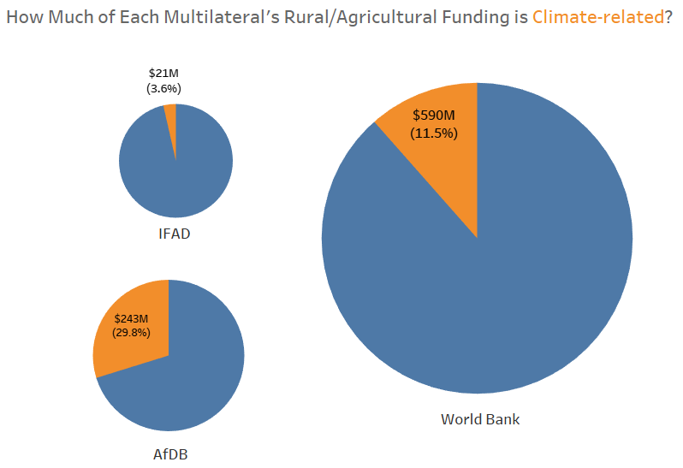
Figure 7: Proportion of climate-related rural agricultural spending by multilateral institution.

Climate-Related On-Farm Financing
Over three-quarters of the agricultural projects are classified as on-farm (N_{on-farm} = 388, N_{rural agricultural} = 505). When using the narrower flag for on-farm projects (those directly affecting smallholder agriculture), the AfDB is most active with 35.7% of on-farm projects being climate-related, compared to 13.0% and 9.9% of World Bank and IFAD on-farm projects, respectively. The AfDB also contributes the largest proportion of on-farm lending to climate-related projects – 29.8%, compared to the World Bank and IFAD’s 14.5% and 5.5%, respectively.
Table 3: Proportion of climate-related on-farm activities financing projects by multilateral institution.
Multilateral | Climate-Related On-Farm Projects | Non-climate Related On-Farm Projects | Total On-Farm Projects
World Bank | N = 23  13.0% | N = 154  87.0% | N = 177  100%
AfDB | N = 50  35.7% | N = 90  64.3% | N = 140  100%
IFAD | N = 7  9.9% | N = 64  90.1% | N = 71  100%
Total | N = 80  20.6% | N = 308  79.4% | N = 388  100%

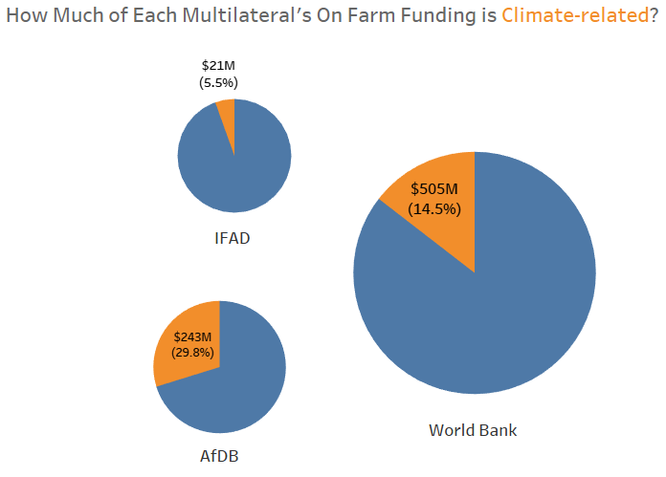
Figure 8: Proportion of climate-related on-farm activities spending by financing institution.

Agricultural Emphasis Within Climate Lending
Considering all lending from these multilaterals devoted to climate-related work, we observe relatively high proportions of projects devoted to rural agricultural economies and on-farm activities: 43.8% and 39.4%, respectively. All of IFAD’s climate-related projects are both rural agricultural and on-farm-related (N = 7). Over half of the World Bank-funded climate projects (55.2%) are rural agricultural economies-related, and 39.7% are related to on-farm activities. The AfDB has the lowest proportion of climate projects devoted to both rural agricultural economies (36.2%) and on-farm activities (also 36.2%); all climate-related agricultural projects funded by the AfDB are on-farm related.

Table 4: Proportion of rural agricultural economies-focused climate financing projects by financing institution.
Multilateral | Rural Ag-Related Climate Projects | Non-Rural Ag-Related Climate Projects | Total Climate Projects
World Bank | N = 32  55.2% | N = 26  44.8% | N = 58  100%
AfDB | N = 50  36.2% | N = 88  63.8% | N = 138  100%
IFAD | N = 7  100% | N = 0  0% | N = 7  100%
Total | N = 89  43.8% | N = 114  56.2% | N = 203  100%

Table 5: Proportion of on-farm-focused climate financing projects by financing institution.
Multilateral | On-Farm Related Climate Projects | Non-On-Farm Related Climate Projects | Total Climate Projects
World Bank | N = 23  39.7% | N = 35  60.3% | N = 58  100%
AfDB | N = 50  36.2% | N = 88  63.8% | N = 138  100%
IFAD | N = 7  100% | N = 0  0% | N = 7  100%
Total | N = 80  39.4% | N = 123  60.6% | N = 203  100%

Within annual climate-related lending, IFAD and the World Bank have dedicated larger proportions toward rural/agricultural and on-farm lending than the AfDB. All $20.6 million of annual IFAD climate lending went toward projects with rural/agricultural and on-farm components. The World Bank has contributed 64.9% of its $590 million in annual climate funding to rural/agricultural economies-related projects, and 55.5% to on-farm lending as a subset of rural/agricultural projects. The AfDB only devotes 23.4% ($243 million) of average annual climate lending toward rural/agricultural and on-farm-related projects.

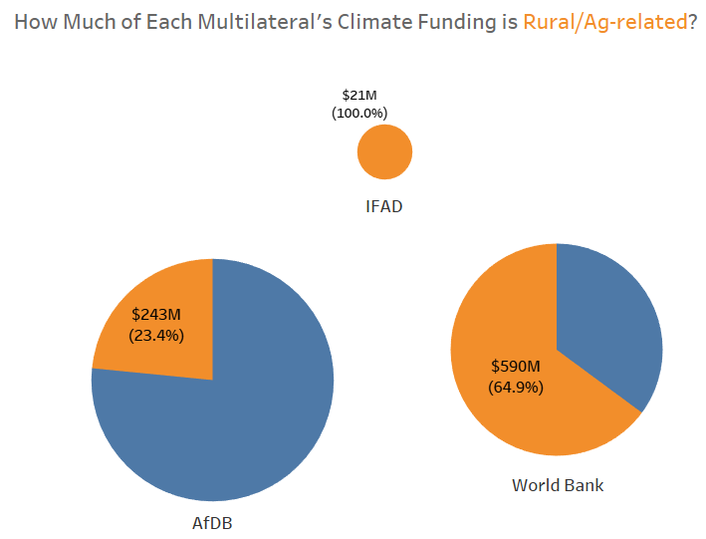
Figure 9: Proportion of rural/agricultural economies-focused climate spending by financing institution.

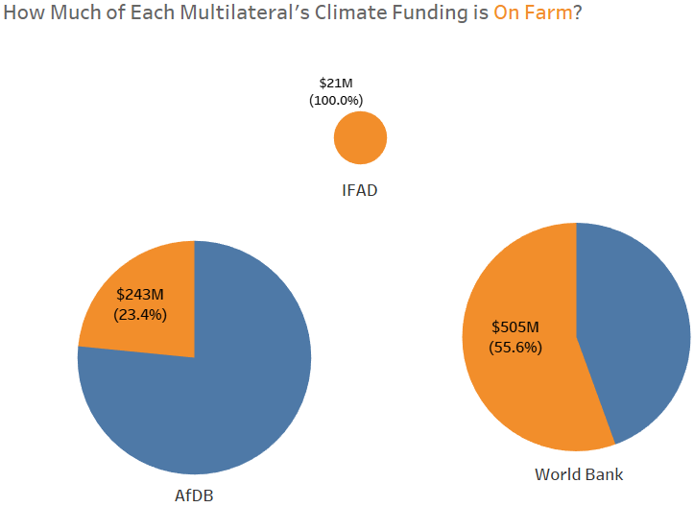
Figure 10: Proportion of on-farm focused climate spending by financing institution.

Country-Level Analysis of Climate-Related Agriculture Borrowing
The second question asked which countries are borrowing most for climate-related agricultural projects and if the amount of borrowing is correlated with a country’s climate risk. Annual average borrowing amounts from multilaterals for climate-related rural/agricultural economies projects varies widely across sub-Saharan Africa. The largest borrowers include Ethiopia ($150 million), Nigeria ($105 million), and Kenya ($102 million). Botswana and Zimbabwe borrowed the least for climate-related rural/agriculture work: $542,000 and $216,000, respectively.
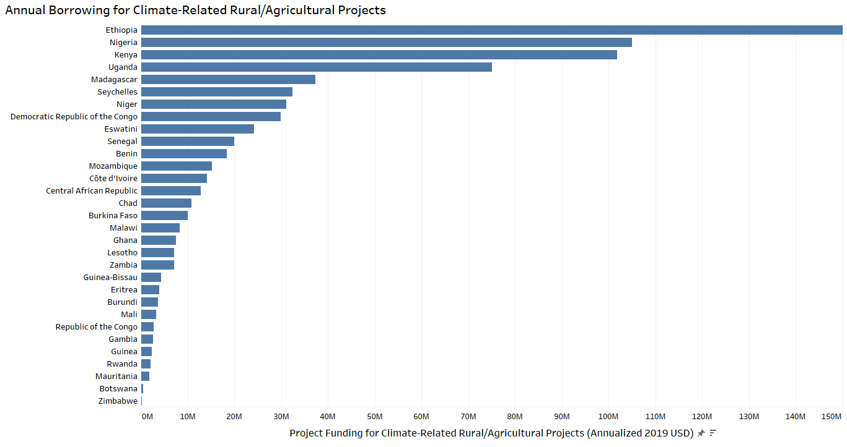
Figure 11: Average annualized borrowing amount (2019 USD) for climate-related rural agricultural economies projects by country.

The proportion of multilateral borrowing for climate-related projects among all rural/agricultural borrowing also varies substantially across sub-Saharan Africa. The Seychelles and Eswatini devote the largest proportions of rural/agricultural borrowing toward climate investments (100% and 69.8%, respectively). Many countries devote between 15% and 30% of rural/agricultural borrowing to climate-related projects (N = 14) and several countries in our dataset have not received any multilateral financing for climate-related rural/agricultural economies projects (N = 15). See Appendices D & E for country-level borrowing amounts for climate-related on-farm projects and proportions of on-farm borrowing devoted to climate work.
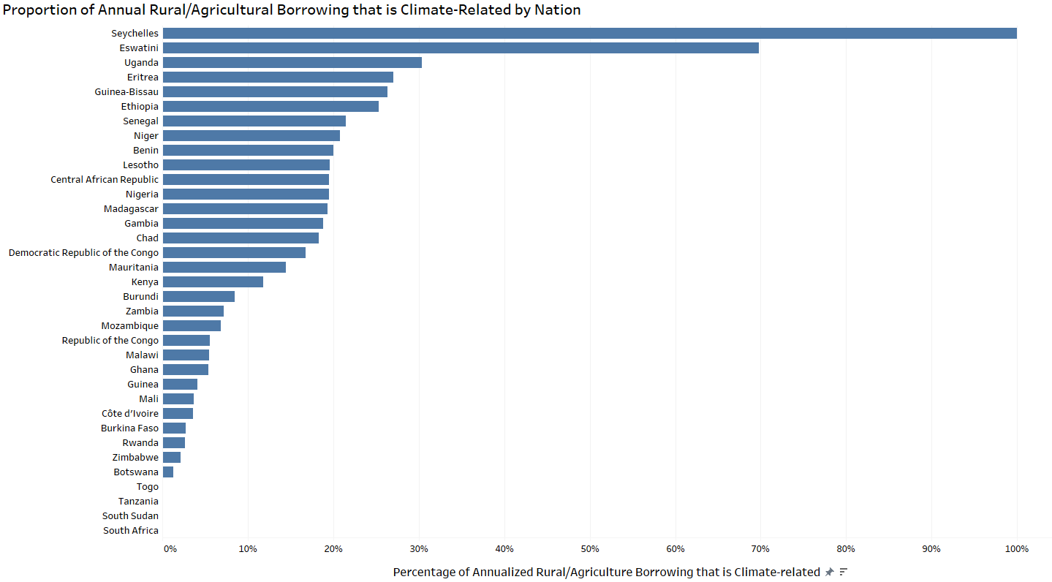
Figure 12: Proportion of average annualized borrowing (2019 USD) for climate-related rural agricultural economies projects among all rural agricultural funding by country.

Through a very simple initial OLS regression check, we do not detect a statistically significant relationship between a country’s Climate Risk Index and its proportion of annual rural/agricultural economies borrowing that is focused on climate. Similarly, we did not find a predictive relationship between CRI and the proportion of annualized on-farm borrowing for climate-related projects.
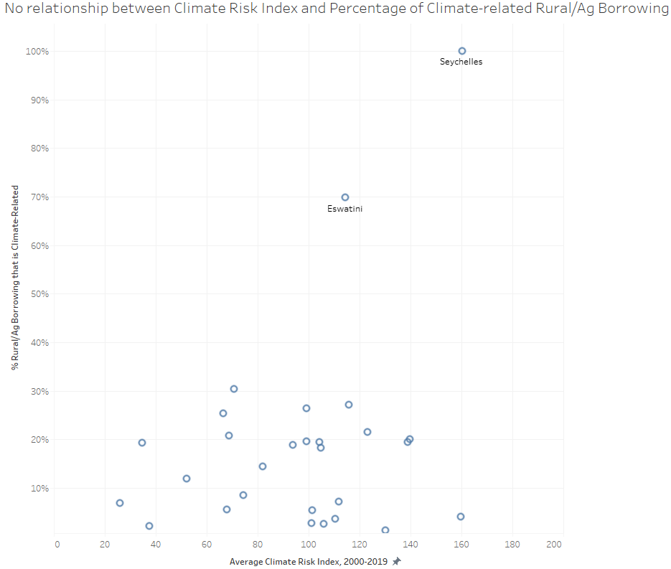
Figure 13: Proportion of climate-related rural/agricultural economies borrowing among all rural/agricultural financing by Climate Risk Index.

Limitations
This paper provides an in-depth look at the contributions of three multilaterals to climate and rural/agricultural projects in sub-Saharan Africa with several limitations outlined below.
Multilateral Project Data Quality
The project data collected from the multilateral websites was neither complete nor perfectly updated. Project descriptions were unavailable on the IFAD website, likely resulting in the undercounting of climate-related projects. Almost 15% of the sample (359 projects) did not have sector data and were dropped from the analysis. Finally, ten projects had no project commitment amounts and were dropped from the analysis.

Methodology
This analysis does not provide a complete representation of the intersection between rural/agricultural and climate funding in SSA as it only focuses on three of the many multilateral funding sources. It also excludes bilateral and private institution funding as well as budgets from the SSA nations themselves. These funding sources must be explored in order to fully understand the intersection of rural/agricultural and climate project funding in SSA. Furthermore, our methods attribute all funding for projects flagged as being climate-related to climate work; this may overstate the actual amount of financing for climate as a subset of overall project budgets.
In addition, the climate flagging methodology employed the use of keyword filtering which may introduce systematic inclusion or exclusion errors.
Climate Risk Index
While useful in giving a historical summary of past climate vulnerability, the CRI does not predict future vulnerability or measure the impact of slow-onset processes like rising sea levels or ocean warming. “Moreover, the data only reflects the direct impacts (direct losses and fatalities) of extreme weather events, whereas, indirect impacts (e.g. as a result of droughts and food scarcity) are not captured” (David Eckstein et al., 2021). As noted by Lempert (2021), an aggregate climate risk score is likely insufficient for decision-makers because it cannot capture enough information to accurately reflect the many and variable impacts of climate change.
Additionally, the CRI does not currently include 2019 scores for Equatorial Guinea or Sao Tome and Principe, both of which were excluded from our regressions for this reason.

Areas for Future Research
This contribution provides a deep-dive into three multilateral funding institutions' financial commitments to SSA agricultural and climate projects. Further research may seek to distinguish between climate adaptation and mitigation projects in order to further understand the landscape of climate-related funding in SSA agriculture. Additionally, merging the rich agricultural project database with the OECD climate project database for additional analysis could provide a more complete picture of current financing in SSA. Future work could also focus on bilateral funding of SSA agricultural projects in order to complement the multilateral perspective in this paper (as well as incorporating additional multilateral funding sources). Finally, future research may incorporate additional measures of climate risk, especially those that attempt to measure the indirect impacts of climate risk in order to create a more robust index of nations’ climate risk.

Conclusion
This work was undertaken to gain a project-level look at lending for climate within agricultural development and describe, to some degree, government and IFI priorities. The World Bank, IFAD, and AfDB currently devote approximately 13% of rural agricultural funding in Sub-Saharan Africa to climate-related work, though this varies between financing institutions. From the recipient perspective, we observe that funding for climate-related rural agriculture also varies widely across SSA countries, averaging 12% of annual rural agricultural financing. Though we didn’t find a predictive relationship between Climate Risk Index and the proportion of rural agricultural financing going toward climate at the country level, it is likely that a combination of climate risk and other factors such as political leadership and country demographics influence funding decisions. In the future, we aim to expand the IFI database to include project level funding from as many donors and investors as feasible and incorporate additional drivers of financing and measures of climate risk.

References
African Development Bank. (2019, April 17). Climate Investment Funds (CIF) [Text]. African Development Bank Group; African Development Bank Group. https://www.afdb.org/en/topics-and-sectors/initiatives-partnerships/climate-investment-funds-cif

Ahamer, G. (2021). International Financial Institutions Ask to Contribute to Climate Protection. Finance Theory and Practice, 25, 6–23. https://www.researchgate.net/publication/354103801_International_Financial_Institutions_Ask_to_Contribute_to_Climate_Protection

Bureau of Labor Statistics. (2020, January 16). Consumer Price Index: 2019 in review. U.S. Bureau of Labor Statistics. https://www.bls.gov/opub/ted/2020/consumer-price-index-2019-in-review.htm

David Eckstein, Vera Künzel, & Laura Schäfer. (2021). Global Climate Risk Index 2021 (p. 50). Germanwatch. https://www.germanwatch.org/sites/default/files/Global%20Climate%20Risk%20Index%202021_2.pdf

de Janvry, A., Sadoulet, E., & Murgai, R. (2002). Rural development and rural policy (pp. 1593–1658) [Handbook of Agricultural Economics]. Elsevier. https://econpapers.repec.org/bookchap/eeehagchp/3-31.htm

FAO. (2022a). Adaptation and Mitigation. Food and Agriculture Organization of the United Nations. https://www.fao.org/climate-change/our-work/what-we-do/adaptation-mitigation/en/

FAO. (2022b). Koronivia Joint Work on Agriculture. Food and Agriculture Organization of the United Nations. https://www.fao.org/koronivia/en/

Gert-Jan Nabuurs, Rachid Mrabet, Assem Abu Hatab, Mercedes Bustamante, Harry Clark, Petr Havlík, Joanna House, Cheikh Mbow, Karachepone Ninan, Alexander Popp, Stephanie Roe, Brent Sohngen, & Sirintornthep Towprayoon. (n.d.). Chapter 7: Agriculture, Forestry and Other Land Uses (AFOLU) (No. 6; IPCC Assessment Report). Intergovernmental Panel on Climate Change.

Hefeker, C. (2006). Project Aid or Budget Aid? The Interests of Governments and Financial Institutions. Review of Development Economics, 10(2), 241–252. https://doi.org/10.1111/j.1467-9361.2006.00315.x

IEG. (2012). The Matrix System at Work: An Evaluation of the World Bank’s Organizational Effectiveness. World Bank. https://doi.org/10.1596/978-0-8213-9715-2

IFAD. (n.d.). Development Topics. IFAD. Retrieved May 30, 2022, from https://www.ifad.org/en/topics

Lempert, R. J. (2021). Measuring global climate risk. Nature Climate Change, 11(10), 805–806. https://doi.org/10.1038/s41558-021-01165-9

Lowder, S. K., Skoet, J., & Raney, T. (2016). The Number, Size, and Distribution of Farms, Smallholder Farms, and Family Farms Worldwide. World Development, 87, 16–29. https://doi.org/10.1016/j.worlddev.2015.10.041

McGuigan, C., Reynolds, R., & Wiedmer, D. (2002). Poverty and Climate Change: Assessing Impacts in Developing Countries and the Initiatives of the International Community. The Overseas Development Institute. https://citeseerx.ist.psu.edu/viewdoc/download?doi=10.1.1.546.1053&rep=rep1&type=pdf

OECD. (n.d.-a). Climate Change: OECD DAC External Development Finance Statistics. OECD.Org. Retrieved May 30, 2022, from https://www.oecd.org/dac/financing-sustainable-development/development-finance-topics/climate-change.htm

OECD. (n.d.-b). Development finance standards. OECD.Org. Retrieved May 30, 2022, from https://www.oecd.org/dac/financing-sustainable-development/development-finance-standards/

OECD. (n.d.-c). Multilateral Development Finance. OECD.Org. Retrieved May 30, 2022, from https://www.oecd.org/dac/financing-sustainable-development/development-finance-topics/multilateralaid.htm

OECD. (n.d.-d). OECD DAC Rio Markers for Climate Handbook. OECD. Retrieved May 30, 2022, from https://www.oecd.org/dac/environment-development/Revised%20climate%20marker%20handbook_FINAL.pdf

OECD. (n.d.-e). Official development assistance – definition and coverage. OECD.Org. Retrieved June 16, 2022, from https://www.oecd.org/dac/financing-sustainable-development/development-finance-standards/officialdevelopmentassistancedefinitionandcoverage.htm

OECD. (2018). Climate-related Development Finance Data (p. 12). https://www.oecd.org/dac/financing-sustainable-development/development-finance-topics/Climate-related-development-finance-in-2018.pdf

OECD. (2022). Climate-related Official Development Assistance (ODA): A Snapshot. OECD. https://www.oecd.org/dac/financing-sustainable-development/development-finance-data/climate-related-official-development-assistance-2019.pdf

Rayner, T., Oberthür, S., & Hermwille, L. (2021). A sectoral perspective on international climate governance: Key findings and research priorities. Earth System Governance, 8, 100105. https://doi.org/10.1016/j.esg.2021.100105

Scott, S. (2015). The accidental birth of “official development assistance” (p. 28). OECD. https://read.oecd-ilibrary.org/development/the-accidental-birth-of-official-development-assistance_5jrs552w8736-en

Sector Coding Guide for Global Affairs Canada Partners. (2011, August 16). Global Affairs Canada. https://www.international.gc.ca/development-developpement/partners-partenaires/bt-oa/sectorcoding_partners-codageprojets_partenaires.aspx?lang=eng

Simon, G. (2018). Methodological Note on the OECD-DAC Climate-related Development Finance Databases. https://www.oecd.org/dac/financing-sustainable-development/development-finance-data/METHODOLOGICAL_NOTE.pdf

UNCC. (2014, August 1). IPCC AR5: Key findings on implications for agriculture. United Nations Climate Change. https://unfccc.int/news/latest-ipcc-science-on-implications-for-agriculture

World Bank. (n.d.). Common Principles for Climate Mitigation Finance Tracking. World Bank. Retrieved May 30, 2022, from https://www.worldbank.org/content/dam/Worldbank/document/Climate/common-principles-for-climate-mitigation-finance-tracking.pdf

World Resources Institute. (n.d.). What is an INDC? World Resources Institute. Retrieved May 12, 2022, from https://www.wri.org/indc-definition

Appendices

Appendix A: On-farm and rural agricultural economies categorization
International Fund for Agriculture
Sectors | On-Farm | Rural Agricultural Economies
Agricultural Development | ✔ | ✔
Credit and Financial Services | ✔ | ✔
Fisheries | ✔ | ✔
Irrigation | ✔ | ✔
Livestock | ✔ | ✔
Marketing/Storage/Processing |  | ✔
Research/Extension/Training | ✔ | ✔
Rural Development |  | ✔

African Development Bank
Sectors | On-Farm | Rural Agricultural Economies
Agricultural Policy and administrative management | ✔ | ✔
Agricultural water resources | ✔ | ✔
Agro-industries | ✔ | ✔
Air transport
Basic life skills for youth
Education policy and administrative management
Electric power transmission and distribution (centralised grids)
Environmental policy and administrative management
Fishery development | ✔ | ✔
Food crop production | ✔ | ✔
Forestry development |  | ✔
Formal sector financial intermediaries
General personnel services
Geothermal energy
Health policy and administrative management
Higher education
Hydro-electric power plants
Immediate post-emergency reconstruction and rehabilitation
Industrial crops/export crops | ✔ | ✔
Industrial policy and administrative management
Infectious disease control
Information services
Livestock | ✔ | ✔
Mineral/mining policy and administrative management
N/A
National road construction
National gas-fired electric power plants
Population policy and administrative management
Primary education equivalent for adults
Public transport services
Rail transport
Rural development |  | ✔
Sanitation - large systems
Small and medium-sized enterprises (SME) development |  | ✔
Solar energy for centralised grids
Telecommunications
Urban development
Vocational training
Water sector policy and administrative management
Water transport
Wind energy
Women’s rights organisations and movements, and government institutions

World Bank
Sectors | On-Farm | Rural Agricultural Economies
(Historic) Macro/non-trade
(Historic) Public financial management
Adult Basic and Continuing Education
Agricultural Extension Research and Other Support Activities | ✔ | ✔
Agricultural markets commercialization and agri-business |  | ✔
Aviation
Banking Institutions
Capital Markets
Central Government (Central Agencies)
Crops | ✔ | ✔
Early Childhood Education
Energy Transmission and Distribution
Fisheries | ✔ | ✔
Forestry |  | ✔
Health
Health Facilities and Construction
Housing Construction
ICT Infrastructure
ICT Services
Insurance and Pension
Irrigation and Drainage | ✔ | ✔
Law and Justice
Livestock | ✔ | ✔
Manufacturing
Mining
Non-Renewable Energy Generation
Oil and Gas
Other Agriculture Fishing and Forestry | ✔ | ✔
Other Education
Other Energy and Extractives
Other Industry
Other Information and Communications Technologies
Other Non-Bank Financial Institutions
Other Public Administration
Other Transportation
Other Water Supply
Ports/Waterways
Power
Primary Education
Public Administration - Agriculture Fishing & Forestry | ✔ | ✔
Public Administration - Education
Public Administration - Energy and Extractives
Public Administration - Financial Sector
Public Administration - Health
Public Administration - Industry
Public Administration - Information and Communications Technologies
Public Administration - Social Protection
Public Administration - Transportation
Public Administration - Water
Railways
Renewable Energy Biomass
Renewable Energy Geothermal
Renewable Energy Hydro
Renewable Energy Solar
Renewable Energy Wind
Renewable Energy
Rural and Inter-Urban Roads |  | ✔
Sanitation
Sanitation and Waste Management
Secondary Education
Services
Social Protection
Sub-National Government
Tertiary Education
Tourism
Trade
Trade and Services
Urban Transport
Waste Management
Water Supply
Workforce Development and Vocational Education

Appendix B: Average annualized borrowing amount (2019 USD) for climate-related rural agricultural economies projects by country.
Country | Annual Borrowing for Climate-Related Rural Agricultural Projects
Ethiopia | $150 million
Nigeria | $105 million
Kenya | $102 million
Uganda | $75.1 million
Madagascar | $37.3 million
Seychelles | $32.4 million
Niger | $31.1 million
Democratic Republic of the Congo | $29.9 million
Eswatini | $24.3 million
Senegal | $19.9 million
Benin | $18.5 million
Mozambique | $15.2 million
Côte d'Ivoire | $14.2 million
Central African Republic | $12.8 million
Chad | $10.8 million
Burkina Faso | $10.1 million
Malawi | $8.39 million
Ghana | $7.61 million
Lesotho | $7.14 million
Zambia | $7.13 million
Guinea-Bissau | $4.37 million
Eritrea | $4.00 million
Burundi | $3.70 million
Mali | $3.34 million
Republic of the Congo | $2.80 million
Gambia | $2.71 million
Guinea | $2.43 million
Rwanda | $2.17 million
Mauritania | $1.80 million
Botswana | $542,000
Zimbabwe | $216,000

Appendix C: Proportion of average annualized borrowing (2019 USD) for climate-related rural agricultural economies projects among all rural agricultural funding by country.
Country | Proportion of Annual Borrowing for Climate-Related Rural Agricultural Projects
Seychelles | 100.0%
Eswatini | 69.8%
Uganda | 30.3%
Eritrea | 27.1%
Guinea-Bissau | 26.3%
Ethiopia | 25.3%
Senegal | 21.5%
Niger | 20.8%
Benin | 20.0%
Lesotho | 19.6%
Central African Republic | 19.5%
Nigeria | 19.5%
Madagascar | 19.4%
Gambia | 18.8%
Chad | 18.3%
Democratic Republic of the Congo | 16.8%
Mauritania | 14.4%
Kenya | 11.8%
Burundi | 8.4%
Zambia | 7.2%
Mozambique | 6.8%
Republic of the Congo | 5.6%
Malawi | 5.5%
Ghana | 5.3%
Guinea | 4.1%
Mali | 3.7%
Côte d'Ivoire | 3.6%
Burkina Faso | 2.7%
Rwanda | 2.7%
Zimbabwe | 2.2%
Botswana | 1.3%
Angola | 0.0%
Cabo Verde | 0.0%
Cameroon | 0.0%
Comoros | 0.0%
Equatorial Guinea | 0.0%
Gabon | 0.0%
Liberia | 0.0%
Mauritius | 0.0%
Namibia | 0.0%
Sao Tome and Principe | 0.0%
Sierra Leone | 0.0%
South Africa | 0.0%
South Sudan | 0.0%
Tanzania | 0.0%
Togo | 0.0%

Appendix D: Average annualized borrowing amount (2019 USD) for climate-related on-farm projects by country.
Country | Annual Borrowing for Climate-Related On-Farm Projects
Ethiopia | $150.0 million
Nigeria | $105.0 million
Kenya | $102.0 million
Uganda | $75.1 million
Seychelles | $32.4 million
Niger | $27.9 million
Eswatini | $24.3 million
Benin | $18.5 million
Democratic Republic of the Congo | $15.8 million
Mozambique | $15.2 million
Côte d'Ivoire | $14.2 million
Senegal | $12.4 million
Chad | $10.8 million
Burkina Faso | $10.1 million
Malawi | $8.4 million
Lesotho | $7.1 million
Zambia | $4.9 million
Guinea-Bissau | $4.4 million
Eritrea | $4.0 million
Burundi | $3.7 million
Mali | $3.3 million
Republic of the Congo | $2.8 million
Gambia | $2.7 million
Guinea | $2.4 million
Rwanda | $2.2 million
Mauritania | $1.8 million
Botswana | $542,000
Zimbabwe | $216,000

Appendix E: Proportion of average annualized borrowing (2019 USD) for climate-related on-farm projects among all on-farm funding by country.
Country | Proportion of Annual Borrowing for Climate-Related On-Farm Projects
Seychelles | 100.0%
Eswatini | 72.6%
Uganda | 64.9%
Guinea-Bissau | 36.1%
Ethiopia | 35.2%
Nigeria | 31.5%
Benin | 31.1%
Chad | 28.9%
Eritrea | 27.1%
Niger | 26.8%
Lesotho | 24.9%
Gambia | 18.8%
Senegal | 14.5%
Mauritania | 14.4%
Kenya | 11.8%
Burundi | 11.2%
Democratic Republic of the Congo | 10.8%
Guinea | 10.6%
Mozambique | 9.0%
Côte d'Ivoire | 8.0%
Zambia | 7.3%
Republic of the Congo | 6.3%
Malawi | 5.9%
Mali | 4.6%
Rwanda | 4.4%
Burkina Faso | 3.5%
Botswana | 2.2%
Zimbabwe | 2.2%
Angola | 0.0%
Cabo Verde | 0.0%
Cameroon | 0.0%
Central African Republic | 0.0%
Comoros | 0.0%
Equatorial Guinea | 0.0%
Gabon | 0.0%
Ghana | 0.0%
Liberia | 0.0%
Madagascar | 0.0%
Mauritius | 0.0%
Namibia | 0.0%
Sao Tome and Principe | 0.0%
Sierra Leone | 0.0%
South Africa | 0.0%
South Sudan | 0.0%
Tanzania | 0.0%
Togo | 0.0%

Appendix F: Key for project standardization
 | African Development Bank | International Fund for Agriculture | World Bank
Countries included | 46 countries of interest + multinational | 46 countries of interest | 46 countries of interest + regional projects in Central Africa, Eastern Africa, Western Africa, Southern Africa
Description | Provided project description + project objectives | Descriptions for most projects unavailable | Provided description
Commitment Amount (USD) | Provided commitment amount, converted to 2019 USD | Provided IFAD Financing amount, converted to 2019 USD | Total IDA and IBRD Commitment + Grant Amount, converted to 2019 USD
Status | Approved or Implementation | Ongoing, Signed, Approved, or Planned | Active or Pipeline
Approval Date | Approval Date | Approval Date | Board Approval Date
Closing Date | Planned Completion Date | Extraction of end year based on approval date and duration | Closing Date
Project Duration | Planned Completion Date - Approval Date | Closing Date - Approval Date | Closing Date - Board Approval Date
Primary Sector | Sector | Sector | Sector 1
Secondary Sector | DAC5 Code Description + Detailed DAC Description | N/A | Sector 2; Sector 3

This aid is allocated to projects that promote economic development, food security, and poverty reduction. (OECD, n.d.-b, n.d.-e).
INDCs are publicly stated climate actions outlined by countries party to the Paris Agreement, embodying national efforts to reduce emissions and adapt to the impacts of climate change. They are the “primary means for governments to communicate internationally the steps they will take to address climate change in their own countries. INDCs reflect each country’s ambition for reducing emissions, taking into account its domestic circumstances and capabilities.”
Climate change mitigation refers to “human interventions to reduce the emissions of greenhouse gases by sources or to enhance their removal from the atmosphere by ‘sinks’”, thus referring to the prevention of climate change impacts. In contrast, adaptation refers to the response to, rather than the prevention of, climate change impacts: “The vital response to the adverse effects of climate and the preparation for future impacts.”
All dollar amounts in 2019 USD.
Our scripts pulled project data on May 4th, 2022. Project data published on the multilaterals’ websites after this date is not included in our analysis nor are projects that had closed by that date.
DAC sector codes are five-digit codes developed by the OECD Development Assistance Committee (DAC). They were defined and standardized to track aid flows to different economic sectors. The code is determined by which sector is targeted by the transfer of aid and not the means of delivery. For example, agricultural entrepreneurship training would be coded under agriculture, and not under education or SME development.
We excluded some human capital (health and education), financial capital, institutional and infrastructure investments that support rural economic development and inclusive agricultural transformation in order to make categories consistent among all IFIs (including IFAD which only tracks agricultural sectors).
In our initial dataset (N = 2,480), a total of 10 projects report $0 in funding, seven of which are excluded from analysis prior to formally excluding projects reporting a $0 commitment amount.
These are specifically rural agricultural economies-flagged projects, the broader project flag for agriculture projects.
Not to scale: IFAD funding size increased for visibility.
See Appendix B for a full list of climate-related rural/agricultural economies borrowing from WB, AfDB, and IFAD by country.
See Appendix C for a full list of climate-related rural/agricultural economies borrowing proportions from WB, AfDB, and IFAD by country.
Beta coefficient on CRI = 0.0005785, t = 0.69, p = 0.494. N = 43. R-squared = 0.0115.
Beta coefficient on CRI = 0.0004908, t = 0.51, p = 0.610. N = 43. R-squared = 0.0064.

